


Workforce Disability Equality Standard Report
2025-2026


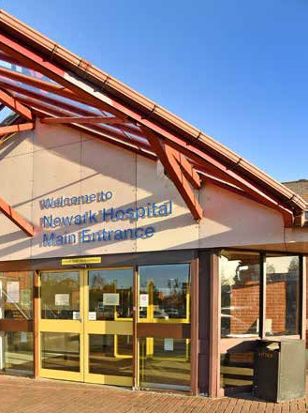
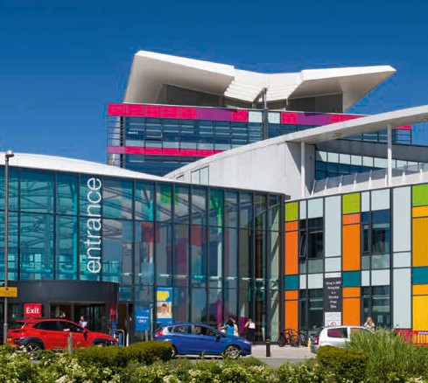

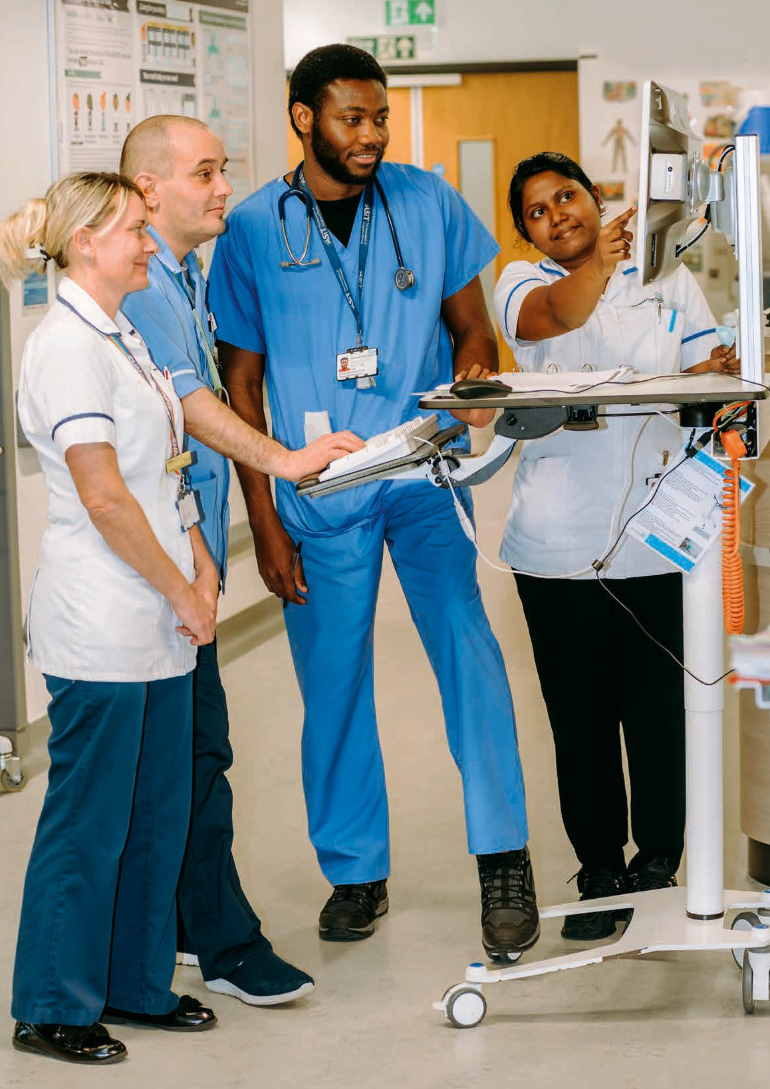

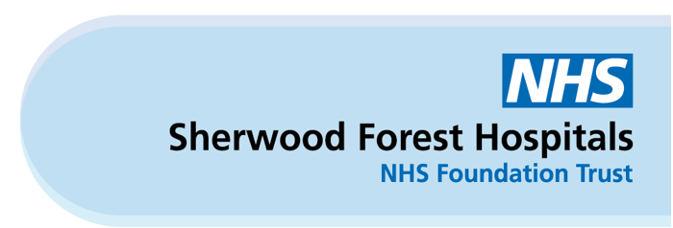
Contents

Introduction 4
Our Community 4
WDES data from 31st March 2026 5
WDES data from 31st March 2026 continued 6
WDES Action Plan 2025-26 update 7
WDES Action Plan 2026-27 8
Conclusion 11

Introduction

The Workforce Disability Equality Standard (WDES) is a set of eleven specific measures (metrics) which enable NHS organisations to review the workplace and career experiences of our colleagues who have declared that they have a disability on their Electronic Staff Record (ESR) against those who have not.
Here at Sherwood, we review the data to identify disparity in the experiences of colleagues and then use the findings to inform the actions we will take to reduce disparity and ensure a continued culture of belonging at Sherwood where colleagues can thrive. Our actions for 2026/27 are contained within this report.
We provide a year-on-year comparison to show the changes against each of the indicators.
The workforce information data contained within this report is from 31st March 2026 and the staff survey data is from the NHS Staff Survey results from the survey that was undertaken in 2025.
In addition to supporting our colleagues, the WDES enables us to ensure our workforce reflects the disability diversity within our local community and will provide confidence to the communities we serve that we are representative of them and that the care we provide will be sensitive to their needs.

Our Community

The 2021 Census data shows that across the populations of Mansfield, Ashfield and Newark and Sherwood, an average of 7% of our citizens identified as having a disability defined under the Equality Act 2010.
Specifically, 9.63% have a disability that limits activity a lot and 11.6% where activity is limited a little. A further 6.73% noted that whilst they didn’t have a disability as defined by the Equality Act 2010, they have a long term physical or mental health condition.
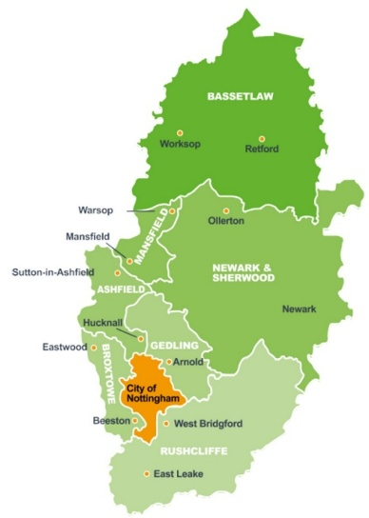

WDES data from 31st March 2026
WRES Metric | 2025 | 2026 | Notes
1. Percentage of staff in AfC pay bands or medical and dental subgroups and very senior managers (including Executive Board members) compared with the percentage of staff in the overall workforce. (Workforce Data) | 7.3% | 8.3% | Again this year, we have seen an increase in the number of colleagues noting their disability on the Electronic Staff Record (ESR). We recognise that we continue to have disparity between ESR and Staff Survey where 23.8% of respondents noted they have a disability.
2. Relative likelihood of non-Disabled staff being appointed from shortlisting compared to Disabled staff (Workforce Data) | 0.87 | 0.91 | Our result for recruitment of disabled applicants is positive and is very close to parity (1.00). We continue to be reassured through our data that non-Disabled staff are not more likely to be appointed than those without a disability.
3. Relative likelihood of Disabled staff compared to non-disabled staff entering the formal capability process, as measured by entry into the formal capability procedure. (Workforce Data) | 0.00 | 4.71 | We have recorded one disabled member of staff entering the formal process this year whereas previously we had none; this is the reason for the increase in this indicator. It is important to note that two non-disabled staff entered the process which is assurance that disabled staff are not more likely to enter it.
4. Percentage of Disabled staff compared to non-disabled staff experiencing harassment, bullying or abuse from:
i. Patients/service users, their relatives or other members of the public (Staff Survey) | 29.7% | 34.0% | Despite a decrease last year, this indicator has increased, and we continue to sit above the national average of 29.7%.
ii. Managers (Staff Survey) | 11.8% | 12.6% | We have seen a slight increase on this indicator from the 2025 staff survey although the Trust remains below the national average of 13.6%.
iii. Other colleagues (Staff Survey) | 22.8% | 28.2% | An increase is observed for this indicator this year after seeing a reduction last year. The Trust now sits above the national average of 22.9%.
5. Percentage of Disabled staff compared to non-disabled staff saying that the last time they experienced harassment, bullying or abuse at work, they or a colleague reported it (Staff Survey). | 51.5% | 51.8% | The percentage of staff reporting incidents has increased slightly and is above the percentage of non-disabled staff reporting (51.3%). Whilst steady progress is evident, we remain below the national average of 54.9%.

WDES data from 31st March 2026 continued
WRES Metric | 2025 | 2026 | Notes
6. Percentage of Disabled staff compared to non-disabled staff believing that the Trust provides equal opportunities for career progression or promotion (Staff Survey). | 56.4% | 45.7% | A significant decrease has been seen this year for this indicator and is a disparate result when compared to non-disabled staff where the percentage increased in the 2025 staff survey overall (54.1% compared to 52.7% in 2024). Our result is below the national average of 48.6%.
7. Percentage of Disabled staff compared to non-disabled staff saying that they have felt pressure from their manager to come to work, despite not feeling well enough to perform their duties (Staff Survey). | 29.6% | 32.4% | Our result has increased for this indicator despite being stable for the last two years. The gap between disabled and non-disabled staff has also increased this year and is 10.8% higher than non-disabled staff who indicated they have felt pressure from their manager to come to work (21.6%).  Our results are higher than the national average of 25.6%.
8. Percentage of Disabled staff compared to non-disabled staff saying that they are satisfied with the extent to which their organisation values their work (Staff Survey). | 38.1% | 31.5% | This indicator has deteriorated again this year and the gap between disabled and non-disabled staff for this indicator has increased (41.6% of non-disabled staff are satisfied; 10.1% gap).  We are performing below the national average of 34.4%.
9. Percentage of Disabled staff saying that their employer has made adequate adjustment(s) to enable them to carry out their work (Staff Survey). | 74.2% | 72.6% | We have seen a reduction in this indicator this year and a reduction at national level has also been observed. The reduction in our result means we continue to perform below the national average of 75%.
10 a) The staff engagement score for Disabled staff, compared to non-disabled staff and the overall engagement score for the organisation (Staff Survey).  10 b) Has your Trust taken action to facilitate the voices of Disabled staff in your organisation to be heard? | 6.7  Yes | 6.2  Yes | Our engagement score decrease follows a national trend although we are now just below the national average of 6.3.  Our WAND Staff Network provides a safe space for colleagues to share experiences and supports awareness-raising activity to inform, educate and improve outcomes for disabled staff.
11. Percentage difference between the organisations’ Board voting membership and its overall workforce. (Workforce Data) | 5.2% | 10.4% | We have seen a further increase in disabled representation at Board level which has now exceeded the Trust overall total. This provides reassurance that our Board is representative of the Trust overall and our local community.

WDES Action Plan 2025-26 update

Annually, we identify three key objectives to be taken forward from our WDES data to reduce the disparate experience of disabled colleagues. The following is an update on last year’s action plan.
What we said we would do | What we did
1. Ensure our disabled aspiring leaders are supported to develop their full potential by promoting coaching through the staff network and agreeing targets for disability representation of Leadership Development programmes. | - We have promoted the Trusts coaching offer during WAND Staff Network safe spaces to ensure aspiring leaders are able to access this support in their career development.  - We have agreed targets for disabled staff representation on the Leadership Development Programme.
2. Increase the number of disabled colleagues who feel valued by the Trust through engagement activities. | - We developed Disability Awareness e-learning including:  - Disability Awareness  - Hearing Loss Awareness  - Supporting Neurodiverse Colleagues  We have also added The Accessible Information Standard training to our e-learning academy using the the E-learning for Health course.  - We ran some focussed activities during Deaf Awareness Week to highlight ‘top-tips’ that support people with hearing loss to highlight the value small adjustments can make for individuals.  - During Disability History Month, three colleagues (including our Staff Network Executive Sponsor) shared their personal stories of working at Sherwood with a disability; their moving and inspiring stories expressed how they have been supported and have felt valued during their employment with Sherwood.
3. Improve the number of colleagues who are being provided with reasonable adjustments. | - We ran a communications campaign during April 2025 following the release of the 2024 Staff Survey results to appeal to Staff Survey respondents to update their ESR record along with promoting the benefits of doing so which included reasonable adjustments.  - We heavily promoted reasonable adjustments in the staff stories during Disability History Month 2025.  - We include reasonable adjustments in our Leadership Development Programme (EDI sessions).

WDES Action Plan 2026-27

Objective | Action | Owner | Metric to improve | Date for completion
1. Address perceptions of equal opportunities for career progression. | Undertake a qualitative review with disabled staff, through focus groups and listening events, to understand barriers to career progression and consider actions to take forward based on this review. | People EDI Lead  WAND Staff Network Co-Chairs | 6 | End of Quarter 3
 | Conduct quarterly review of disabled staff representation on the Leadership Development Programme to ensure targets for representation are being met. | People EDI Lead  People Development Team | 6 | Ongoing
 | Promote availability of coaching for those with disabilities and long-term health conditions who are wanting to advance their career in the Trust. | People EDI Lead  People Development Team  WAND Staff Network Co-Chairs | 6 | End of Quarter 3
2. Increase number of staff satisfied with the extent that the organisation values their work. | All Divisions to plan for and celebrate Disabled colleagues during National Inclusion Week and Disability History Month in 2026 and share activity with People EDI Lead for publishing in the Trust Communications Bulletin during these periods. | Divisional People Leads  People EDI Lead | 8 | End of Quarter 3
 | Provide clear communication about the Trust’s commitment to supporting staff with disabilities and long-term heath conditions during National Inclusion Week and Disability History Month in 2026. | People EDI Lead | 8 | End of Quarter 2
3.Increase the number of staff reporting they are receiving reasonable adjustments. | Review Reasonable Adjustments Guidance with support from WAND Staff Network members ensuring clarity on flexible/agile working as a reasonable adjustment, a clear process for acquiring equipment and clarity on the Access to Work process to support leaders.  Once updated promote the guidance under our ‘Together We Will’ initiative to ensure colleagues are supported with the right equipment and adjustments to succeed in their role. | People EDI Lead  Communications team | 9 | End of Quarter 3
 | Provide leader masterclasses to support our leaders in implementing reasonable adjustments. | People EDI Lead | 9 | End of Quarter 4
 | Divisions to develop Action Plans to support awareness and embedding of reasonable adjustments and provide update to the People EDI Lead in advance of Disability History Month so actions can be celebrated during the month via the Trust Communications Bulletin. | People EDI Lead  Divisional People Leads  Communications team | 9 | End of Quarter 3
 | Strengthen promotion of reasonable adjustments to increase awareness, encourage timely requests for support, and ensure colleagues with disabilities or long-term health conditions can access the adjustments they need to work effectively and sustainably. | People EDI Lead  Communications team | 9 | End of Quarter 3
4. ESR Declarations | Continue to encourage colleagues to update their disability status on ESR with a focus on reducing percentage of ‘unknown’ entries to better understand the representation of colleagues with disabilities or long-term health conditions working in the Trust. Include ‘unknown’ in quarterly monitoring to track progress. | People EDI Lead  Communications team  People Information team | 1 | Ongoing

Progress against this action plan will be reported through our People Wellbeing and Belonging Sub-Cabinet.

Conclusion

This year’s Workforce Disability Equality Standard (WDES) report highlights areas of positive progress, including improved representation of disabled colleagues and continued progress in recruitment outcomes. There is also evidence of increased reporting reflecting growing confidence among colleagues to share their experiences.
However, the data also identifies several areas of decline. Increases in reports of bullying, harassment and pressure to attend work when unwell, alongside declines in perceptions of career progression, feeling valued, and satisfaction with adjustments, indicate that further focused action is required to improve the day-to-day experience of disabled staff.
It is important to acknowledge that the most deteriorated result relates to staff experiencing bullying and harassment from service users; this has not been noted as an action within the WDES Action Plan as this is also an area of deterioration in our Workforce Race Equality Standard (WRES) and actions to specifically address bullying and harassment have been noted within the WRES action plan and these actions are expected to positively impact the experiences of staff with disabilities and long-term health conditions.
The Trust remains committed to addressing these challenges through the targeted actions set out for 2026/27, with a focus on strengthening manager capability, improving reasonable adjustments, and embedding an inclusive culture where disabled colleagues feel supported, valued and able to thrive.

